InfoPharma Ordering System
IPOS – PU
Online Platform

Summary
This is a Requirements Specification and High-Level Design Document

Authors
Arjun Bector

Dmitrii Shevyrev

Nalah Alghonaim

Nuhur Mohammed

Shirwa Mahamed

Sutharsan Ackshay

Contents
1. Preface 3
1.1 Purpose and scope of the document 3
1.2 Intended audience and Reading Suggestions 3
1.3 History of the document 3
2. Introduction 3
3. Glossary 4
4. System Requirements 5
4.1 Purpose and Scope of the System 5
4.2 Functional System Requirements 5
4.3 Non-Functional System Requirements 6
4.4 Assumptions and Constraints 6
4.5 Use Case Diagram 6
4.6 Use Case Specifications 7
4.7 Prioritised List of Use Cases 27
5. IPOS High-Level Design 30
5.1 IPOS-SA (Server Application) 31
5.2 IPOS-CA (Client Application) 31
5.3 IPOS-PU (Online Platform) 31
5.4 Software Architecture 31
5.5 Design Diagram of subsystem IPOS-PU 32
5.6 Source code (Java) for the interfaces of IPOS_PU 33
5.7 Testing the communication between subsystems 35

1. Preface

1.1 Purpose and scope of the document
This document is a Requirements Specification and High-Level Design document for IPOS-PU (Online Platform) subsystem. It serves as a proposal and technical blueprint for the Customer (Info Pharma Ltd) and the Team Project Management Team.
The document details the functional requirements of the IPOS-PU subsystem and the high-level software architecture for the entire InfoPharma Ordering System (IPOS). Which consists of three subsystems: IPOS-SA, IPOS-CA and IPOS-PU. While this document shows how these subsystems may interact via agreed interfaces it does not cover the internal implementation details of the IPOS-PU subsystem.

1.2 Intended audience and Reading Suggestions
The primary audience includes:
The Customer: Mr. Lancaster (CEO), Mr. Walter (CTO), and Mr. Khan (Head of IT)
Team Consultant: Ali Sarvghad Batn Moghaddam

1.3 History of the document
Version 1.0 Initial draft for the Week 5 deliverable (27 February 2026)

2. Introduction
InfoPharma Ltd, a major pharmaceutical distributor, is transitioning from a traditional paper-based catalogue and moving on from the traditional phone/email ordering system to a modern B2B software application. The InfoPharma Ordering System (IPOS) is broken into three distinct subsystems, the server application (IPOS-SA), the client application (IPOS-CA), and the online platform (IPOS-PU).
The IPOS-PU is the online platform that allows a merchant to sell pharmaceuticals and beauty products directly to the public. Some key features include:
- Member Management: Registration for “commercial” customers (which is passed onto IPOS-SA for due diligence), and “non-commercial” customers
- Sales & Catalogue: Functionality for the customer to filter the products and to use a virtual shopping cart and pay via credit or with debit card or the integrated third-party services like PayPal
- Marketing: Tools for merchants to manage advertising and promotions campaigns with variable discounts
- Conversion Tracking: Monitoring the customer engagement through out their experience by tracking click rate and actual purchases to measure success

3. Glossary
Term | Definition
Actor | A human or external system interacting with the system, such as a Public Member or the IPOS-SA subsystem
B2B | Business-to-Business; refers to software designed for commercial interaction between companies.
CaptureService.com | A 3rd party service providing CAPTURE features to verify human users during registration
CSR | Centre for Software Reliability.
Conversion Rate | The ratio of items purchased to items clicked/included in an order during a promotion campaign.
Interface | A contract defining set abstract operations that a subsystem must provide or require for communication.
IPOS-CA | Client Application; used by merchants in their pharmacy shops to manage local stock and sales
IPOS-PU | The online platform used by merchants for direct sales of pharmaceutical goods to the public
IPOS-SA | Server Application; administered by InfoPharma to maintain the global catalogue and merchant accounts
SMTP | Simple Mail Transfer Protocol: an external service used to send automated emails
UML | Unified Modelling Language; the standard for documenting software development
Use Case | A basic interaction between a system and an actor.

4. System Requirements
This section describes the system requirements for the InfoPharma Ordering System (IPOS), with particular focus on the IPOS-PU subsystem. The requirements defined here specify what the system is expected to do, the constraints under which it operates, and the assumptions made at this stage of development. These requirements form the basis for the subsequent high-level design and interface specifications.

4.1 Purpose and Scope of the System
The purpose of IPOS is to provide an integrated software solution that supports the online and in-store sale of pharmaceutical and beauty products. The system is composed of multiple subsystems, each developed by a separate team, which must cooperate through well-defined interfaces.
The scope of IPOS-PU (Online Platform) includes:
- Enabling public (non-commercial) customers to browse products, place orders, and complete purchases online.
- Supporting commercial customers who require additional registration and approval before accessing certain services or pricing.
- Providing functionality for online sales, promotions, and customer engagement tracking.
- Communicating with other IPOS subsystems to verify customer status and ensure correct handling of inventory and order processing.
The system does not aim to replace in-store pharmacy operations; instead, it complements them by extending sales and customer interaction to an online platform.

4.2 Functional System Requirements
The following functional requirements describe the expected behaviour of the IPOS-PU subsystem at a high level.
IPOS-PU shall:
- Allow users to register as either non-commercial or commercial customers.
- Support the submission of commercial customer registration requests for verification.
- Enable users to browse, search, and filter the online product catalogue.
- Allow users to add products to a shopping cart and place orders.
- Support promotional features such as discounts or campaigns.
- Track customer interactions and sales data for reporting purposes.
Where necessary, IPOS-PU shall obtain external information or services from other IPOS subsystems via defined interfaces rather than implementing such functionality internally.

4.3 Non-Functional System Requirements
The IPOS system, including IPOS-PU, must satisfy the following non-functional requirements:
- Modularity: Each subsystem must be loosely coupled, interacting only through defined interfaces.
- Scalability: The online platform should be capable of supporting growth in the number of users and transactions.
- Maintainability: The system design should allow individual subsystems to evolve independently.
- Security: Customer data and commercial information must be handled securely, with access restricted according to user roles.
- Reliability: Subsystem failures should not compromise the integrity of the entire system.

4.4 Assumptions and Constraints
- The IPOS system consists of multiple subsystems developed independently by separate teams.
- Subsystems interact only through explicitly defined interfaces.
- The system operates without additional security or data-protection mechanisms.
- The system does not handle product returns or refunds.
- Network communication between subsystems is assumed to be available and reliable.

4.5 Use Case Diagram
This section presents the UML use case diagram for the IPOS-PU (Online Platform) subsystem. The internal implementation of IPOS-PU and the behaviour of other subsystems are outside the scope of this model.
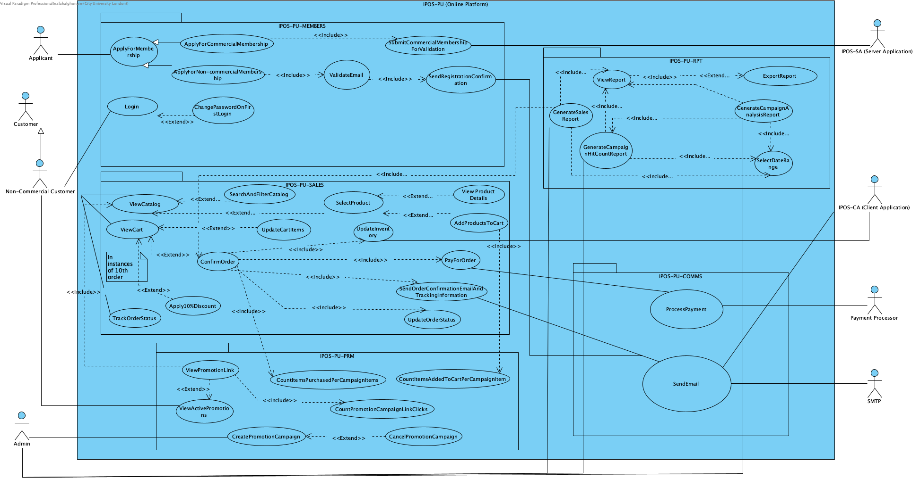

4.6 Use Case Specifications
A set of simplified Use Case Specifications:

Use case ID: UC-MEM-01 | Use case: ApplyForMembership
Brief Description:
Allows an applicant to register for a membership on the IPOS-PU Platform by submitting required registration details
Primary actors:
Applicant
Secondary actors:
IPOS-SA
Preconditions:
-Applicant is not already registered.
IPOS-PU system is operational
Main flow: Not required.
Extension use cases:
- ApplyForCommercialMembership
- ApplyForNonCommercialMembership
Inclusion use cases:
N/A
Postconditions:
- A new membership record is created
- Confirmation email is sent to applicant
Alternative flows:
- Email validation is rejected
- Required fields are missing

Use case ID: UC-MEM-02 | Use case: ApplyForCommercialMembership
Brief Description:
Allows an applicant to apply for a commercial membership account requiring additional business validation
Primary actors:
Applicant
Secondary actors:
IPOS-SA
Preconditions:
- Applicant selects commercial membership type.
Main flow: Not required.
Extension use cases:
N/A
Inclusion use cases:
- SubmitCommercialMembershipForValidation
Postconditions:
- Commercial membership application submitted to IPOS-SA for processing.
Alternative flows:
- Cancel
- Error sending application to IPOS-SA server

Use case ID: UC-MEM-03 | Use case: ApplyForNonCommercialMembership
Brief Description:
Allows an applicant to apply for a non-commercial membership account.
Primary actors:
Applicant
Secondary actors:
N/A
Preconditions:
- Applicant selects non-commercial membership type.
Main flow: Not required.
Extension use cases:
N/A
Inclusion use cases:
- ValidateEmail
- SendRegistrationConfirmation
Postconditions:
- Non-commercial membership account created.
- Confirmation email sent.
Alternative flows:
- Email validation fails

Use case ID: UC-MEM-04 | Use case: SubmitCommercialMembershipApplication
Brief Description:
Submit commercial membership application details to IPOS-SA for approval and confirmation.
Primary actors:
IPOS-SA
Secondary actors:
IPOS-SA
Preconditions:
- Commercial membership application has been completed.
Main flow: Not required.
Extension use cases:
N/A
Inclusion use cases:
N/A
Postconditions:
- Commercial membership status set to “Pending Approval”.
Alternative flows:
- Error sending application to IPOS-SA server.

Use case ID: UC-MEM-05 | Use case: ValidateEmail
Brief Description:
Validates that the email provided during registration is valid and not already in use.
Primary actors:
IPOS-SA
Secondary actors:
N/A
Preconditions:
- An email is provided by a non-commercial applicant.
Main flow: Not required.
Extension use cases:
N/A
Inclusion use cases:
N/A
Postconditions:
- Email marked valid or invalid
Alternative flows:
- Email is already in use and applicant prompted to login instead.

Use case ID: UC-MEM-06 | Use case: SendRegisterationConfirmation
Brief Description:
Sends a confirmation email to the applicant after a successful membership registration in which the applicant’s login details will be provided (email provided as username and randomly generated 10-character password)
Primary actors:
IPOS-PU
Secondary actors:
SMTP
Preconditions:
- Registration successfully completed.
Main flow: Not required.
Extension use cases:
N/A
Inclusion use cases:
N/A
Postconditions:
- Confirmation email delivered to applicant.
Alternative flows:
- Email delivery failure is logged and retried.

Use case ID: UC-MEM-07 | Use case: Login
Brief Description:
Allows a registered non-commercial member to authenticate and access their account on the InfoPharma portal.
Primary actors:
Customer
Secondary actors:
N/A
Preconditions:
- Account exists.
- Valid credential provided.
Main flow: Not required.
Extension use cases:
- ChangePasswordrdOnFirstLogin
Inclusion use cases:
N/A
Postconditions:
- User session started.
Alternative flows:
- Access denied for invalid credentials.

Use case ID: UC-MEM-08 | Use case: ChangePasswordOnFirstLogin
Brief Description:
Forces a first-time login user to change their password upon first login.
Primary actors:
IPOS-PU
Customer
Secondary actors:
N/A
Preconditions:
- User is logging in for the first time.
Main flow: Not required.
Extension use cases:
N/A
Inclusion use cases:
N/A
Postconditions:
- New password stored.
- User redirected to main platform.
Alternative flows:
- Password does not meet security requirements.

Use case ID: UC-SALES-01 | Use case: ViewCatalog
Brief Description: Allows the customer to browse the available products in the online catalog

Primary actors: Non-Commercial Customer, Customer

Secondary actors:

Preconditions: The customer has accessed the IPOS-PU platform
Main flow: Not required.
Extension use cases: SearchAndFilterCatalog, SelectProduct

Inclusion use cases: N/A

Postconditions: The customer is presented with a list of products from the catalog

Alternative flows: If no products are available, the system displays a message indicating the catalog is currently empty

Use case ID: UC-SALES-02 | Use case: ViewCart
Brief Description: Allows the user to view the current items they have selected for purchase

Primary actors: Non Commercial Customer, Customer

Secondary actors: N/A

Preconditions: The customer is interacting with the IPOS-PU platform

Main flow: Not required.
Extension use cases: ConfirmOrder,UpdateCartItems,Apply10%Discount

Inclusion use cases: N/A

Postconditions: The contents of the customers shopping cart are displayed

Alternative flows: If it is the customers 10th order, the system triggers the Apply10%Discount extension.
The customer may choose to modify quantities, triggering UpdateCartItems

Use case ID: UC-SALES-03 | Use case: SearchAndFilterCatalog
Brief Description: Allows the customer to search specific items or filter the catalog based on various criteria to narrow down results

Primary actors: Non-commercial Customer, Customer

Secondary actors: N/A

Preconditions: The customer is interacting with the ViewCatalog use case

Main flow: Not required.
Extension use cases: N/A

Inclusion use cases: N/A

Postconditions: The system displays a filtered or searched list of products to the user

Alternative flows: N/A

Use case ID: UC-SALES-04 | Use case: SelectProduct
Brief Description: Allows the user to choose a specific item from the catalog to see more details or perform further actions.

Primary actors: Non-commercial Customer, Customer

Secondary actors: N/A

Preconditions: The user is currently viewing the catalog through the ViewCatalog use case

Main flow: Not required.
Extension use cases: ViewProductDetails, AddProductsToCart

Inclusion use cases: N/A

Postconditions: The system identifies the selected product for the user to view or to add to their cart

Alternative flows: N/A

Use case ID: UC-SALES-05 | Use case: UpdateCartItems
Brief Description: Allows a customer to modify the contents of their shopping cart, such as changing quantities or removing items.

Primary actors: Non Commercial Customer, Customer

Secondary actors: N/A

Preconditions: The customer is currently interacting with the ViewCart use case

Main flow: Not required.
Extension use cases: N/A

Inclusion use cases: N/A

Postconditions: The shopping cart is update to reflect the customers changes

Alternative flows: N/A

Use case ID: UC-SALES-06 | Use case: ConfirmOrder
Brief Description: Allows user to finalize the items in their cart and proceed toward payment and order completion.

Primary actors: Non Commercial Customer , Customer

Secondary actors: Payment Processor, SMTP

Preconditions: The customer is currently viewing their cart through the ViewCart use case

Main flow: Not required.
Extension use cases: Apply10%Discount

Inclusion use cases: PayforOrder,SendOrderConfirmationEmailandTrackingInformation,UpdateOrderStatus,UpdateInventory,CountItemsPurchasedPerCampaignItem

Postconditions: The order is confirmed, payment is processed, inventory is adjusted, and the user is notified by email

Alternative flows: If the system detects this is the customers 10th order , the Apply10%Discount extension is triggered before final payment

Use case ID: UC-SALES-07 | Use case: Apply10%Discount
Brief Description: This process applies 10% reduction to the total cost of the order when a specific customer loyalty threshold is met.

Primary actors: Non Commercial Customer, Customer

Secondary actors: N/A

Preconditions:The customer is currently interacting with either the ViewCart or ConfirmOrder use cases

Main flow: Not required.
Extension use cases: N/A

Inclusion use cases: N/A

Postconditions: The order total is updated with the 10% discount applied

Alternative flows: The discount is only applied in instances of 10th order from the customer. If this condition is not met, the extension is not triggered and the standard price remains.

Use case ID: UC-SALES-08 | Use case: TrackOrderStatus
Brief Description: Allow a user to monitor the current progress and delivery status of a previously placed order.

Primary actors: Non Commercial Customer, Customer

Secondary actors: N/A

Preconditions: The user is interacting with the IPOS-PU platform

Main flow: Not required.
Extension use cases: N/A

Inclusion use cases: ViewCatalog

Postconditions: The current status of the customer order is displayed

Alternative flows: N/A

Use case ID: UC-SALES-09 | Use case: UpdateInventory
Brief Description: Process that automatically adjusts the stock levels of products once an order has been confirmed

Primary actors: Non Commercial Customer,Customer

Secondary actors: IPOS-CA

Preconditions: An order is being finalized through the ConfirmOrder use case

Main flow: Not required.
Extension use cases: N/A

Inclusion use cases: N/A

Postconditions: The systems inventory levels are reduced by the quantity of items purchased in the confirmed order.

Alternative flows: N/A

Use case ID: UC-SALES-10 | Use case: ViewProductDetails
Brief Description: Allows the user to see in depth information and specifications for a specific item selected from the catalog.

Primary actors: Non Commercial Customer, Customer

Secondary actors: N/A

Preconditions: The customer has triggered the SelectProduct use case from the catalog.

Main flow: Not required.
Extension use cases: N/A

Inclusion use cases: N/A

Postconditions: The detailed information for the selected product is displayed to the customer.

Alternative flows: N/A

Use case ID: UC-SALES-11 | Use case: AddProductsToCart
Brief Description: This process allows the user to add a specific product into their virtual shopping cart.

Primary actors: Non Commercial Customer, Customer

Secondary actors: N/A

Preconditions: The customer has navigated to a specific product through the SelectProduct use case

Main flow: Not required.
Extension use cases: N/A

Inclusion use cases: N/A

Postconditions: The selected item is added to the customers cart and the cart total is updated

Alternative flows: If the item is no longer available in the inventory the system informs the customer and the item is not added to the cart.

Use case ID: UC-SALES-12 | Use case: PayForOrder
Brief Description: This handles the financial transaction process where the customer provides payment details to finalize their purchase.

Primary actors: Non Commercial Customer, Customer

Secondary actors: Payment Processor,IPOS CA

Preconditions: The customer has initiated ConfirmOrder use case

Main flow: Not required.
Extension use cases: N/A

Inclusion use cases: Process Payment

Postconditions: The payment is successfully authorized or captured, allowing the order confirmation flow to proceed

Alternative flows: If the Payment Processor rejects the transaction, the system notifies the user and the order remains unconfirmed

Use case ID: UC-SALES-13 | Use case: SendOrderConfirmationEmailAnd TrackingInformation
Brief Description: This process automates the dispatch of an email to the user containing their receipt and the necessary details to track their package after an order is successfully confirmed.

Primary actors: Non-Commercial Customer, Customer

Secondary actors: SMTP, IPOS CA

Preconditions: The ConfirmOrder use case has reached the stage where the order Is finalized and payment is processed.

Main flow: Not required.
Extension use cases: N/A

Inclusion use cases: SendEmail

Postconditions: An email containing the order confirmation and tracking information is sent to the users registered email address.

Alternative flows: If the SMTP server is unreachable or the email address is invalid the system logs a failure and may attempt to notify the user through IPOS CA.

Use case ID: UC-SALES-14 | Use case: UpdateOrderStatus
Brief Description: This process is responsible for the changing the state of an order from Pending to Confirmed or Shipped.

Primary actors: Non commercial Customer, Customer

Secondary actors: IPOS CA

Preconditions: An order has been initiated or confirmed through the ConfirmOrder Use case

Main flow: Not required.
Extension use cases: N/A

Inclusion use cases: N/A

Postconditions: The order record is updated in the system with the new status, and this change is reflected in IPOS CA.

Alternative flows: If the system is unable to write the new status to the database, an error is logged and the IPOS CA is notified.

Use case ID: UC-PRM-01 | Use case: ViewActivePromotionLink
Brief Description:
Allows a Non-Commercial Customer to view a list of ongoing promotion campaigns via special link called “Promotions”
Primary actors:
Non-Commercial Customer, Customer
Secondary actors:
N/A
Preconditions:
- Customer has access to the IPOS-PU
- There is at least a single active promotion campaign
IPOS-PU system is operational
Main flow: Not required
Extension use cases:
- ViewPromotionsLink
Inclusion use cases:
N/A
Postconditions:
- A page with ongoing promotion campaigns is opened
Alternative flows:
- If there are no active promotions at the moment, the link should display “No promotions are currently active”

Use case ID: UC-PRM-02 | Use case: ViewPromotionsLink
Brief Description:
Opens a list of items that are affected by a specific promotion campaign, from which user can open the dedicated pages for each of those products in a general catalog, and the discount that is applied to those products
Primary actors:
Non-Commercial Customer, Customer
Secondary actors:
N/A
Preconditions:
- Customer clicked the “Promotions” link on the home page

Main flow: Not required.
Extension use cases:
N/A
Inclusion use cases:
- CountPromotionCampaignLinkClicks
- ViewCatalog
Postconditions:
- The page of a specific promotion campaign has been opened
Alternative flows:
N/A

Use case ID: UC-PRM-03 | Use case: CountPromotionCampaignLinkClicks
Brief Description:
IPOS-PU increments a dedicated counter every time a customer visits a promotion campaign page. There is an individual counter for each active campaign
Primary actors:
Non-Commercial Customer, Customer
Secondary actors:
N/A
Preconditions:
- Customer clicked the link for the promotion campaign

Main flow: Not required.
Extension use cases:
N/A
Inclusion use cases:
N/A
Postconditions:
- Counter for the Promotion campaign clicks incremented by 1
Alternative flows:
N/A

Use case ID: UC-PRM-04 | Use case: CountItemsPurchasedPerCampaignItems
Brief Description:
IPOS-PU increments a dedicated counter every time a customer successfully purchased an item from a promotion campaign. There is an individual counter for each item in each active campaign
Primary actors:
Non-Commercial Customer, Customer
Secondary actors:
Payment Processor, SMTP
Preconditions:
- Customer was able to successfully complete an order, part of which was at least one item from an active campaign

Main flow: Not required.
Extension use cases:
N/A
Inclusion use cases:
N/A
Postconditions:
- The purchase counter of the item for the product incremented by the amount of such items that were purchased in the order
Alternative flows:
N/A

Use case ID: UC-PRM-05 | Use case: CountItemsAddedToTheCartPerCampaign
Brief Description:
IPOS-PU increments a dedicated counter every time a customer adds an item from a promotion campaign into the cart. There is an individual counter for each item in each active campaign
Primary actors:
Non-Commercial Customer, Customer
Secondary actors:
N/A
Preconditions:
- Customer added at least one item from a promotion campaign to their cart

Main flow: Not required.
Extension use cases:
N/A
Inclusion use cases:
N/A
Postconditions:
- The cart counter of the item for the product incremented by the amount of such items that were added to the cart
Alternative flows:
N/A

Use case ID: UC-PRM-06 | Use case: CreatePromotionCampaign
Brief Description:
Admin creates a new promotion campaign with at least one item in it and set start and end dates
Primary actors:
Admin
Secondary actors:
N/A
Preconditions:
- Admin is logged into the IPOS-PU
- Admin clicked “Create a promotion campaign” link
Main flow: Not required.
Extension use cases:
- CancelPromotionCampaign
Inclusion use cases:
N/A
Postconditions:
- A new promotion campaign has been added to the database
- A new promotion campaign will be displayed on the list of active promotion campaigns between its star and end dates
- A list of promotion items can be accessed via clicking on the promotion’s link during duration of the campaign
- The discount of the promotion has been applied to all items in the promotion during its duration
Alternative flows:
- If there were no items selected in creation of the promotion, promotion won’t be created
- If no dates have been selected for the promotion, promotion won’t be created
- If the selected dates for the promotion were set in the past, promotion won’t be created
- If the product that is part of the promotions is part of another promotion during overlapping time period, promotion won’t be created

Use case ID: UC-PRM-07 | Use case: CancelPromotionCampaign
Brief Description:
Allows admin to cancel promotion campaign
Primary actors:
Admin
Secondary actors:
N/A
Preconditions:
- There is a promotion campaign that is either active or will become active in the database

Main flow: Not required.
Extension use cases:
N/A
Inclusion use cases:
N/A
Postconditions:
- The campaign has been removed from the list of active campaigns if it was active
- The discount will be removed from the items which are part of the promotion campaign
Alternative flows:
- If campaign’s starting date has not passed, then the campaign will be removed from the campaign database

Use case ID: UC-RPT-01 | Use case: ViewReport
Brief Description:
Allows an admin user to view a generated report within the IPOS-PU platform.
Primary actors:
IPOS-PU
Admin
Secondary actors:
N/A
Preconditions:
- The user is Admin
Main flow: Not required.
Extension use cases:
- ExportReport
Inclusion use cases:
- GenerateSalesReport
- GenerateCampaignHitCountReport
- GenerateCampainAnalysisReport
Postconditions:
- The requested report is displayed to the admin.
Alternative flows:
- If the report cannot be generated (e.g. no data for chosen criteria), the system displays a “no data available message.

Use case ID: UC-RPT-02 | Use case: ExportReport
Brief Description:
Allows an authorised user to export a currently viewed report into a downloadable format.
Primary actors:
IPOS-PU
Admin
Secondary actors:
N/A
Preconditions:
- The user is Admin
- A report is being currently viewed
Main flow: Not required.
Extension use cases:
N/A
Inclusion use cases:
N/A
Postconditions:
- Report is exported and made available.
Alternative flows:
- Export fails due to server error

Use case ID: UC-RPT-03 | Use case: GenerateSalesReport
Brief Description:
Generates a sales report for selected time period and prepares it for viewing.
Primary actors:
IPOS-PU
Admin
Secondary actors:
N/A
Preconditions:
- The user is Admin
- Sales data exists in the system.
Main flow: Not required.
Extension use cases:
N/A
Inclusion use cases:
- SelectDateRange
- ViewReport
Postconditions:
- Sales report is generated and displayed
Alternative flows:
- If no sales data exists for the selected period, the systems returns an empty report

Use case ID: UC-RPT-04 | Use case: GenerateCampaignHitCountReport
Brief Description:
Generates a campaign hit count report for selected time period and prepares it for viewing.
Primary actors:
IPOS-PU
Admin
Secondary actors:
N/A
Preconditions:
- The user is Admin.
- At least one campaign exists in the system.
Main flow: Not required.
Extension use cases:
N/A
Inclusion use cases:
- SelectDateRange
- ViewReport
Postconditions:
- Campaign hit count report is generated and displayed.
Alternative flows:
- If no campaign exists / no activity in the selected range, the system returns an empty report.

Use case ID: UC-RPT-05 | Use case: GenerateCampaignAnalysisReport
Brief Description:
Generates a Campaign Analysis Report for selected time period and prepares it for viewing.
Primary actors:
IPOS-PU
Admin
Secondary actors:
N/A
Preconditions:
- The user is Admin.
- At least one campaign exists in the system.
Main flow: Not required.
Extension use cases:
N/A
Inclusion use cases:
- SelectDateRange
- ViewReport
Postconditions:
- Campaign analysis report is generated and displayed.
Alternative flows:
- If no campaign exists / no activity in the selected range, the system returns an empty report.

Use case ID: UC-RPT-06 | Use case: SelectDateRange
Brief Description:
Allows the user to select a start date and end date used as input for generating reports.

Primary actors:
Admin
Secondary actors:
N/A
Preconditions:
- The user is Admin
- User is generating a report
Main flow: Not required.
Extension use cases:
N/A
Inclusion use cases:
N/A
Postconditions:
- A valid date range is selected and stored for use in report generation.
Alternative flows:
- End date is earlier than start date, so the system prompts user to correct the range.

Use case ID: UC-COMMS-01 | Use case: SentEmail
Brief Description:
The email is sent to the receiver with the content specific to the use case
Primary actors:
IPOS-CA, SMTP
Secondary actors:
Applicant, Customer, Non-Commercial Customer
Preconditions:
- The sender sent an email with the outcome of the process to the IPOS-PU
Main flow: Not required.
Extension use cases:

Inclusion use cases:
N/A
Postconditions:
- The email has been delivered to the receiver with a success
Alternative flows:
N/A

Use case ID: UC-COMMS-02 | Use case: ProcessPayment
Brief Description:
The order’s payment details are sent to the Payment Processor to complete the payment
Primary actors:
Customer, Non-Commercial Customer
Secondary actors:
Payment Processor
Preconditions:
- Customer sent a request with payment details of their orders to the IPOS-PU
Main flow: Not required.
Extension use cases:
N/A
Inclusion use cases:
N/A
Postconditions:
- The order was successfully authorised by the Payment Processor
- The outcome was received by the IPOS-PU
Alternative flows:
- If the payment was not authorised, IPOS-PU will notify the customer that the payment was unsuccessful, and the order will be put on hold

4.7 Prioritised List of Use Cases

The use cases are prioritised according to their importance for the successful launch of IPOS-PU.
Essential – Required for launch
Important – Strongly enhances functionality
Good to have – Can be implemented later

4.7.1 Members
Use Case ID | Use Case Name | Priority | Justification
UC-MEM-01 | ApplyForMembership | Essential | Core entry point for all users.
UC-MEM-02 | ApplyForCommercialMembership | Essential | Required for B2B verification process.
UC-MEM-03 | ApplyForNonCommercialMembership | Essential | Enables public access to platform.
UC-MEM-04 | SubmitCommercialMembershipApplication | Essential | Required to communicate with IPOS-SA for approval.
UC-MEM-05 | ValidateEmail | Important | Improves data quality but system can run without strict validation initially.
UC-MEM-06 | SendRegistrationConfirmation | Essential | Users must receive login credentials.
UC-MEM-07 | Login | Essential | Required to access secured functionality.
UC-MEM-08 | ChangePasswordOnFirstLogin | Important | Improves security but not required for launch.

4.7.2 Sales
Use Case ID | Use Case Name | Priority | Justification
UC-SALES-01 | ViewCatalog | Essential | Core platform functionality.
UC-SALES-02 | ViewCart | Essential | Required for purchasing process.
UC-SALES-03 | SearchAndFilterCatalog | Important | Enhances usability but not strictly required.
UC-SALES-04 | SelectProduct | Essential | Necessary for shopping flow.
UC-SALES-05 | UpdateCartItems | Essential | Required for cart management.
UC-SALES-06 | ConfirmOrder | Essential | Core business functionality.
UC-SALES-07 | Apply10%Discount | Good to have | Loyalty feature, not required for launch.
UC-SALES-08 | TrackOrderStatus | Important | Improves customer experience.
UC-SALES-09 | UpdateInventory | Essential | Required for stock consistency with IPOS-CA.
UC-SALES-10 | ViewProductDetails | Essential | Necessary before purchase decision.
UC-SALES-11 | AddProductsToCart | Essential | Core shopping functionality.
UC-SALES-12 | PayForOrder | Essential | Required to complete transactions.
UC-SALES-13 | SendOrderConfirmationEmailAndTrackingInformation | Essential | Required customer notification.
UC-SALES-14 | UpdateOrderStatus | Essential | Required for order lifecycle management.

4.7.3 Promotions
Use Case ID | Use Case Name | Priority | Justification
UC-PRM-01 | ViewActivePromotionLink | Important | Enhances marketing exposure.
UC-PRM-02 | ViewPromotionsLink | Important | Supports campaign visibility.
UC-PRM-03 | CountPromotionCampaignLinkClicks | Good to have | Analytics feature.
UC-PRM-04 | CountItemsPurchasedPerCampaignItems | Important | Required for campaign performance measurement.
UC-PRM-05 | CountItemsAddedToTheCartPerCampaign | Important | Supports conversion tracking.
UC-PRM-06 | CreatePromotionCampaign | Important | Required for marketing functionality.
UC-PRM-07 | CancelPromotionCampaign | Good to have | Administrative convenience.

4.7.4 Reports
Use Case ID | Use Case Name | Priority | Justification
UC-RPT-01 | ViewReport | Important | Required for business monitoring.
UC-RPT-02 | ExportReport | Good to have | Convenience feature.
UC-RPT-03 | GenerateSalesReport | Essential | Core financial reporting.
UC-RPT-04 | GenerateCampaignHitCountReport | Important | Supports marketing analysis.
UC-RPT-05 | GenerateCampaignAnalysisReport | Important | Helps evaluate campaign effectiveness.
UC-RPT-06 | SelectDateRange | Essential | Required input for report generation.

4.7.5 Comms
Use Case ID | Use Case Name | Priority | Justification
UC-COMMS-01 | SendEmail | Essential | Required for confirmations and notifications.
UC-COMMS-02 | ProcessPayment | Essential | Required for order completion.

5. IPOS High-Level Design
This section defines the high-level design of the entire InfoPharma Ordering System (IPOS) software, which includes its software architecture, the subsystems IPOS is made up of, and the communication interfaces which allow these subsystems to interact. The IPOS architecture is modelled using UML component diagrams, in which each subsystem is represented as a component with stereotype <<subsystem>>.

The subsystems envisaged are:

5.1 IPOS-SA (Server Application)
IPOS-SA is the server-side subsystem administered by InfoPharma. It is responsible for the global management of product catalogue and merchant-related data, and for server-side services needed to support both the pharmacy client application and the online platform. In particular, IPOS-SA supports due-diligence and approval processes for commercial customers/merchants, and provides services and data needed by the other subsystems to operate reliably and consistently.

5.2 IPOS-CA (Client Application)
IPOS-CA is the client application used by merchants in their pharmacy shops. It supports in-store operations related to sales and stock handling, including maintaining or interacting with local inventory/stock information needed to fulfil orders. The client application must communicate with IPOS-SA and (where required) the online platform to ensure that catalogue and inventory-related operations remain consistent across the system.

5.3 IPOS-PU (Online Platform)
IPOS-PU is the online platform that allows a merchant to sell pharmaceutical and beauty products directly to the public. Key functional areas of IPOS-PU include:
- Member management: registration of commercial and non-commercial customers, including the submission of commercial registrations for verification via IPOS-SA.
- Sales and catalogue: browsing/filtering products, shopping cart management, checkout, and order placement.
- Marketing: promotion and campaign management (e.g., discount rules) and tracking user engagement.
- Conversion tracking and reporting: monitoring customer engagement and purchases, and generating administrative reports.
Internally, IPOS-PU may be organised into managers responsible for the main areas of functionality (e.g., membership, sales, communications, promotions, reporting), but detailed internal design is outside the scope of this deliverable and will be developed later.

5.4 Software Architecture

The architecture of InfoPharma Ordering System as a UML component diagram, made in Visual Paradigm, is shown below in Figure 2 in Lollipop notations, and in Figure 3 in class notation.
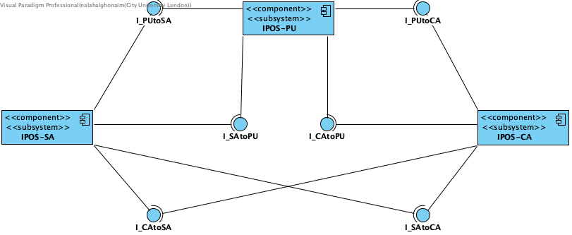
Figure 2. InforPharma Ordering Systems as a UML component diagram (Lollipop Notation).
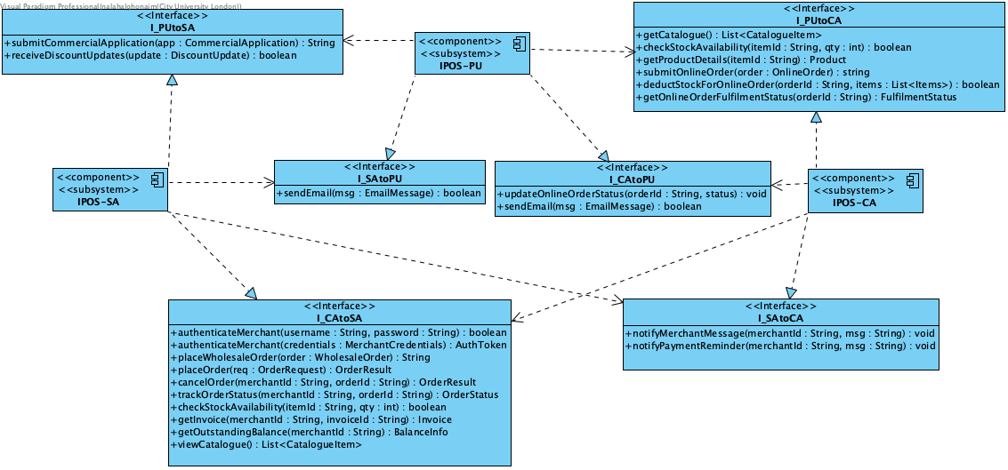 Figure 3. InforPharma Ordering Systems as a UML component diagram (Class Notation).

5.5 Design Diagram of subsystem IPOS-PU

Additionally, an elaborate UML class design diagram of the subsystem IPOS-PU, showing its required interfaces, as well as its provided interfaces with their implementation classes, is shown below in Figure 4.
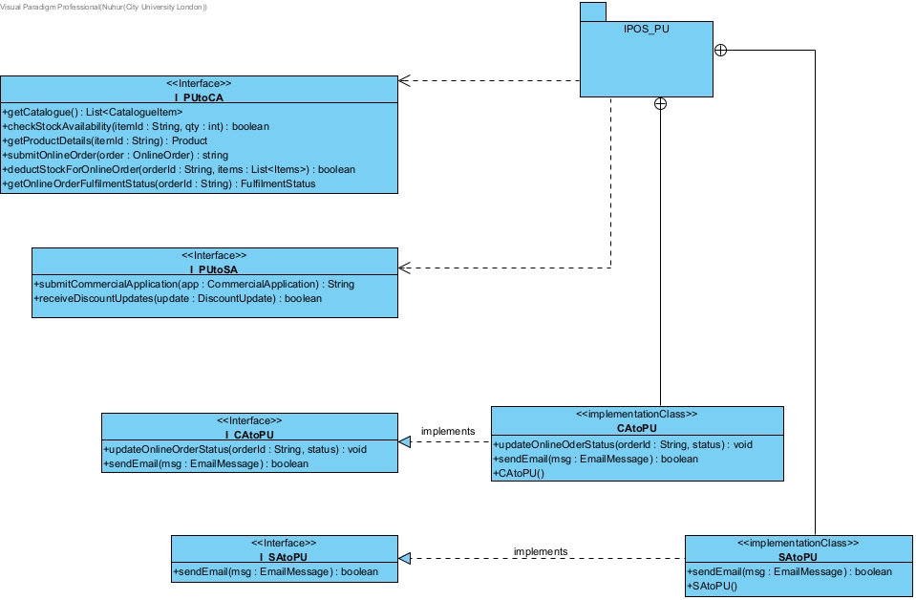

Figure 4. High Level Design of IPOS_PU Subsystem

5.6 Source code (Java) for the interfaces of IPOS_PU
The following Java source code has been generated from the design class diagram fragment of the IPOS-PU subsystem. The interfaces define the contracts for communication between IPOS-PU and the other subsystems (IPOS-CA and IPOS-SA). The implementation classes realise the respective interfaces.

package IPOS_PU.IPOS_PU;
public class CAtoPU implements I_CAtoPU {
/**
*
* @param orderld
* @param status
*/
public void updateOnlineOderStatus(String orderld, int status) {
// TODO - implement CAtoPU.updateOnlineOderStatus
throw new UnsupportedOperationException();
}
/**
*
* @param msg
*/
public boolean sendEmail(EmailMessage msg) {
// TODO - implement CAtoPU.sendEmail
throw new UnsupportedOperationException();
}
public CAtoPU() {
// TODO - implement CAtoPU.CAtoPU
throw new UnsupportedOperationException();
}
}
---------------------------------------
I_CAtoPU.java
public interface I_CAtoPU {
public void updateOnlineOrderStatus(String aOrderId, Object aStatus);
public boolean sendEmail(EmailMessage aMsg);
}
---------------------------------------
I_PUtoCA.java
public interface I_PUtoCA {
public List<CatalogueItem> getCatalogue();
public boolean checkStockAvailability(String aItemId, int aQty);
public Product getProductDetails(String aItemId);
public String submitOnlineOrder(OnlineOrder aOrder);
public boolean deductStockForOnlineOrder(String aOrderId, List<Items> aItems);
public FulfilmentStatus getOnlineOrderFulfilmentStatus(String aOrderId);
}
---------------------------------------

I_PUtoSA.java
public interface I_PUtoSA {
public String submitCommercialApplication(CommercialApplication aApp);
public boolean receiveDiscountUpdates(DiscountUpdate aUpdate);
}
---------------------------------------
I_SAtoPU.java
public interface I_SAtoPU {
public boolean sendEmail(EmailMessage aMsg);
}
---------------------------------------
package IPOS_PU.IPOS_PU;
public class SAtoPU implements I_SAtoPU {
/**
*
* @param msg
*/
public boolean sendEmail(EmailMessage msg) {
// TODO - implement SAtoPU.sendEmail
throw new UnsupportedOperationException();
}
public SAtoPU() {
// TODO - implement SAtoPU.SAtoPU
throw new UnsupportedOperationException();
}
}

5.7 Testing the communication between subsystems

Method | Test ID |  | Parameter | Comment | Expected Outcome
CAtoPU.updateOnlineOrderStatus(String orderId, int status) | 1 | orderId = "ORD123"  status = 1 |  | Order exists  Status value is valid | Method completes without exception. Order status updated from previous value to 1 in the system.
CAtoPU.updateOnlineOrderStatus(String orderId, int status) | 2 | orderId = "INVALID"  status = 1 |  | Order does not exist | No status update performed. System state unchanged. Error handled without crashing.
CAtoPU.updateOnlineOrderStatus(String orderId, int status) | 3 | orderId = "ORD123"  status = -1 |  | Order exists Status value is invalid | No update performed. Order retains original status. Validation handled correctly.
CAtoPU.updateOnlineOrderStatus(String orderId, int status) | 4 | orderId = ""  status = 1 |  | Empty order id provided | No update performed. Method handles invalid input safely.
CAtoPU.sendEmail(EmailMessage msg): boolean | 5 | msg = valid EmailMessage with recipient, subject, body |  | Email message contains all required fields | Method returns true. Email is sent and logged in system.
CAtoPU.sendEmail(EmailMessage msg): boolean | 6 | msg = null |  | Null message provided | Method returns false. No email sent. No system crash.
CAtoPU.sendEmail(EmailMessage msg): boolean | 7 | msg = EmailMessage with empty recipient |  | Required field missing | Method returns false. Email not sent  No email record created
I_PUtoCA.getCatalogue(): List<CatalogueItem> | 8 | No parameters |  | Catalogue contains items in database | Returns non empty list of Catalogue Item objects with correct details
I_PUtoCA.getCatalogue(): List<CatalogueItem> | 9 | No parameters |  | Catalogue is empty | Returns empty list  No exception thrown
I_PUtoCA.checkStockAvailability(String itemId, int qty): boolean | 10 | itemId = "ITEM1"  qty = 5 |  | Item exists  Requested quantity less than or equal to available stock | Method returns true  Stock level remains unchanged
I_PUtoCA.checkStockAvailability(String itemId, int qty): boolean | 11 | itemId = "ITEM1"  qty = 500 |  | Item exists  Requested quantity exceeds available stock | Method returns false  Stock level remains unchanged
I_PUtoCA.checkStockAvailability(String itemId, int qty): boolean | 12 | itemId = "INVALID"  qty = 5 |  | Item does not exist
  Method returns false
  No stock record modified
I_PUtoCA.checkStockAvailability(String itemId, int qty): boolean | 13 | itemId = "ITEM1"  qty = -1 |  | Item exists  Quantity is negative | Method returns false  Input validation prevents processing
I_PUtoCA.getProductDetails(String itemId): Product | 14 | itemId = "ITEM1" |  | Item exists in catalogue | Returns Product object with correct id, name, price, and stock values
I_PUtoCA.getProductDetails(String itemId): Product | 15 |  |  | Item does not exist
  itemId = "INVALID"
  Returns null
  No exception thrown
I_PUtoCA.submitOnlineOrder(OnlineOrder order): String | 16 | order = valid OnlineOrder with existing items and quantities |  | Order data valid  All items exist and stock sufficient | Returns generated order id  Order stored in system with correct details
I_PUtoCA.submitOnlineOrder(OnlineOrder order): String | 17 | order = null |  | Null order submitted | Returns null. No order created  System state unchanged
I_PUtoCA.deductStockForOnlineOrder(String orderId, List<Items> items): boolean | 18 | orderId = "ORD123"  items = valid list with sufficient stock |  | Order exists  Items exist  Stock sufficient | Method returns true  Stock quantity reduced correctly for each item
I_PUtoCA.deductStockForOnlineOrder(String orderId, List<Items> items): boolean | 19 | orderId = "ORD123"  items = list with insufficient stock |  | Order exists At least one item has insufficient stock | Method returns false  No stock deducted for any item
I_PUtoCA.deductStockForOnlineOrder(String orderId, List<Items> items): boolean | 20 | orderId = "INVALID"  items = valid list |  | Order does not exist | Method returns false  Stock unchanged
I_PUtoCA.getOnlineOrderFulfilmentStatus(String orderId): FulfilmentStatus | 21 | orderId = "ORD123" |  | Order exists | Returns correct FulfilmentStatus value that matches stored order state
I_PUtoCA.getOnlineOrderFulfilmentStatus(String orderId): FulfilmentStatus | 22 | orderId = "INVALID" |  | Order does not exist | Returns null  No exception thrown
I_PUtoSA.submitCommercialApplication(CommercialApplication app): String | 23 | app = valid CommercialApplication with required fields |  | Application data valid | Returns generated application reference id  Application stored successfully
I_PUtoSA.submitCommercialApplication(CommercialApplication app): String | 24 | app = null |  | Null application submitted | Returns null  No application created
I_PUtoSA.receiveDiscountUpdates(DiscountUpdate update): boolean | 25 |  |  | Discount update contains valid item id and percentage | Method returns true  Discount applied to relevant products
  update = valid DiscountUpdate
I_PUtoSA.receiveDiscountUpdates(DiscountUpdate update): boolean | 26 | update = null |  | Null update received | Method returns false  No discount changes made
SAtoPU.sendEmail(EmailMessage msg): boolean | 27 | msg = valid EmailMessage |  | Email contains valid recipient and content | Method returns true  Email successfully sent and recorded
SAtoPU.sendEmail(EmailMessage msg): boolean | 28 | msg = null |  | Null message provided | Method returns false  No email sent. System remains stable

